**Homework 4 – Act 2 – Step 1 - Writeup**

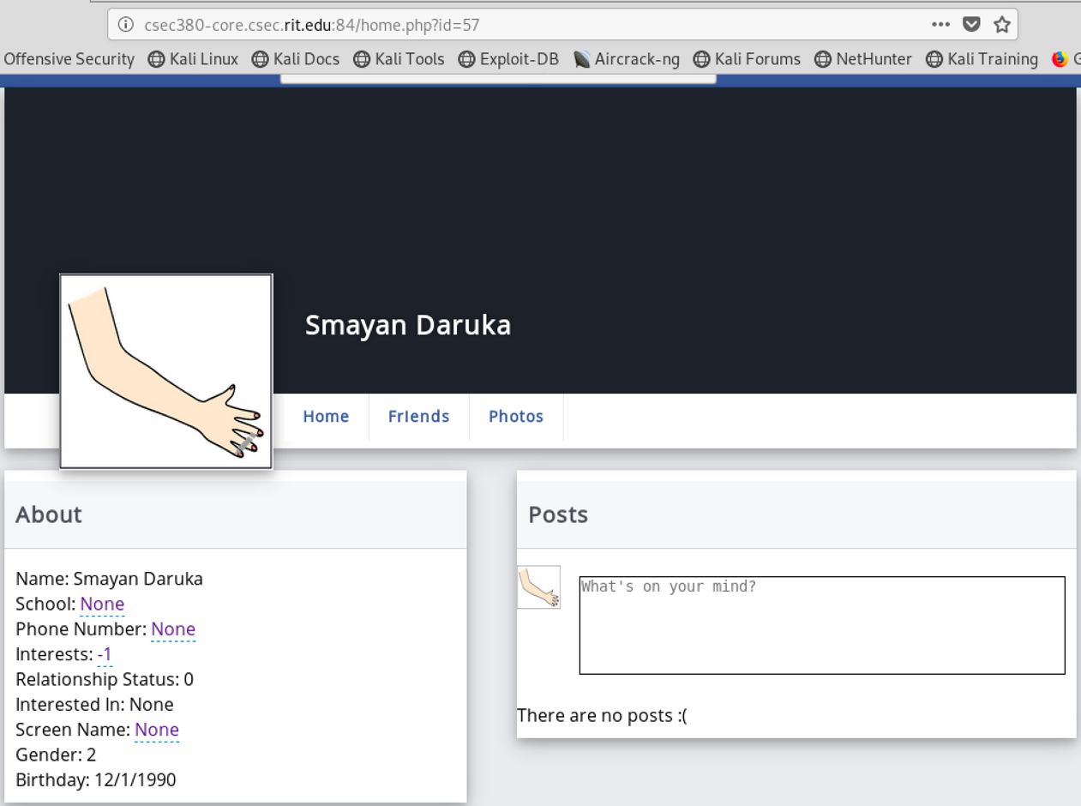

The above picture shows my profile ID, which is 57. The picture below shows the link I posted on the message board.

The URL, when clicked on, automatically adds the person associated with the specific ID as a friend.

The images below show that Jon Doe has successfully added me. There are 4 screenshots since my name is at the bottom of the page.

